**Personal Portfolio – Nicola Gunn n8871809**

1. **User Stories and Rating Technique (MOSCOW)**

a) Media Vault

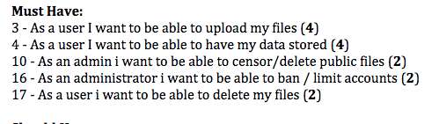

***Figure 1.1***

The first artifact is the user stories and the application of the MOSCOW technique in developing a prioritized list of user stories. The user stories were put into their priority rating – must have, should have, could have, and won’t have. The number next to the user stories above in Figure 1.1 are the determined length of time it would take to accomplish the outcome for that user story. This was performed as a team using the poker game technique during a workshop time.

b) Property Development

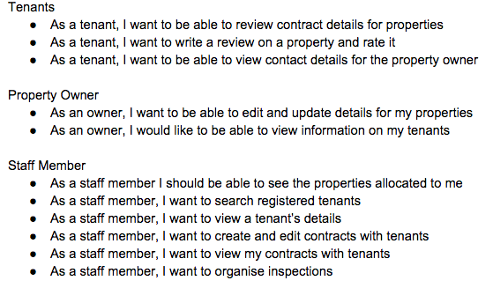

***Figure 1.2***

The user stories for the client team were split up throughout the group and we were to use the MOSCOW technique again. This was for the client team to compare against their prioritization and use it as another reference and guide for finalising the list. The client team also completed this for us. Above in figure 1.2 are the user stories that I contributed using the MOSCOW technique.

1. **Release Plan**

a)

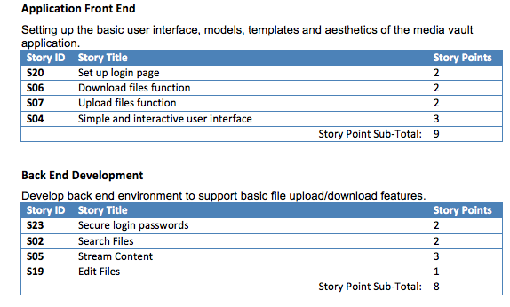

***Figure 2.1***

Starting with release one on the release plan the set up of the user stories into Application Front End and Back End Development was contributed. It is to provide guidance for the computer science students to develop the project in a structured manor. The team then worked on determining the story points of each user story in this first release, evident in Figure 2.1.

b)

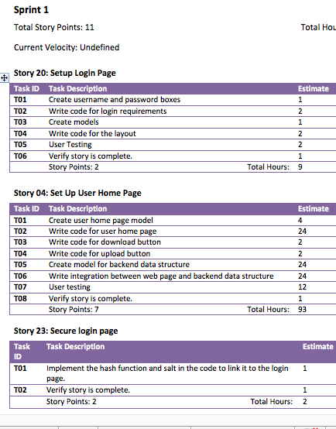

***Figure 2.2***

Following on from release one sprint one was completed. Sprint 1 determines more in depth of the most important user stories – as seen above in Figure 2.2. With confirmation from a computer science student on some processes of completion of the user story the Task Descriptions were completed. The estimate times were then determined, also with reference to other team members to ensure agreement.

c)

Work on Release 2 and Sprint 2 is underway however still in progress by the team and myself. The original release 2 and sprint 2 had to update due to some tasks not being completed from sprint 1. Additionally some tasks from sprint 2 were completed instead in sprint 1.

1. Team Blog

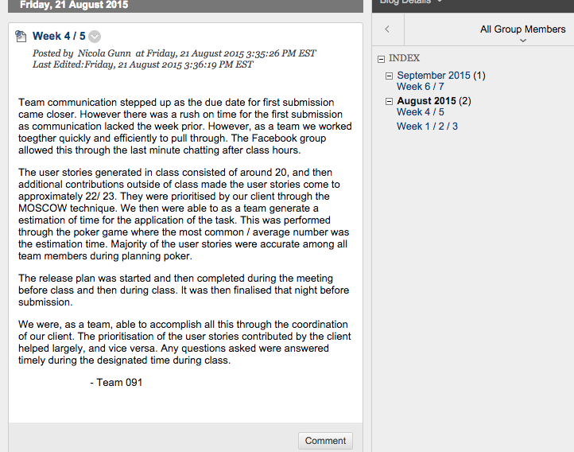

***Figure 3***

I have solely completed fortnightly contributions to the team blog. In some parts of the blog where information is included about particular aspects of the project I confer with other team members. On the most part I have completed the blogs away from the group. The blogs are a way of reflecting on the progress of the team and whether the team agreement is being adhered to and the team is on track. It also allows any improvements of the team to be noted and acknowledged if nothing has changed. It is also a way to keep track of the behavior and synergy of the team as a whole.

1. Team 92 Review Letter

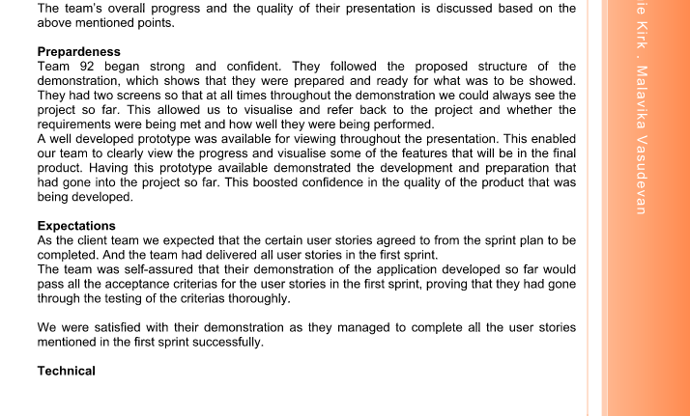

***Figure 4***

Lastly the team completed a peer review on the client team. The layout of the letter was put onto Google drive for the entire team to contribute. I made contributions to the “Expectations”, “Technical” and “Professionalism” parts. Most of it is the first small paragraph and from there other members added on to answer the required content. I completed the “Preparedness” (evident in figure 4) part entirely. Originally my work was to allow a rough guide for other members to contribute and add on however in the end it became the final copy for that part.